**Problem statement-1.1: Injecting dependencies**

Write an Employee bean. Inject values into bean using DI and display all values. Refer the class diagram below

The output would look as shown below:

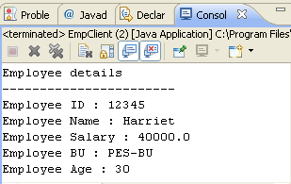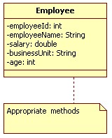

Class Diagram 1: Employee

 Keep each of the lab solutions separate, preferably in different packages/source folders

**Problem statement-1.2: Injecting dependencies**

Code SBU bean. Revisit the Employee bean and provide a method to retrieve SBU details (getSBUDetails()) for the employee. You will need to inject the SBU bean to the Employee bean as shown in the Class diagram below:

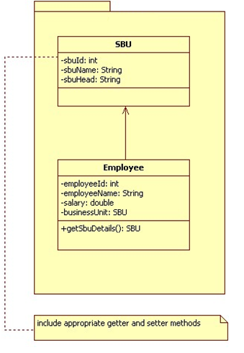

Class Diagram 2: **SBU and Employee**

The output would look as shown below:

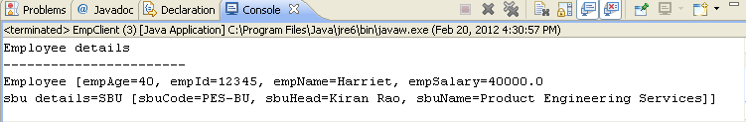

**Problem statement-1.3: Injecting dependencies**

Revisit the SBU bean. Create a new property called empList which will contain a list of all employees in the PES BU. Display the SBU details, followed by a list of all employees in that BU. To inject employee objects into the SBU bean, use “List” collection. Allocate two employees to PES. Refer Class diagram below

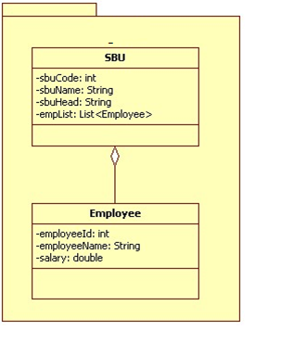

Class Diagram 3: **SBU and Employee (Ver -2)**

The output would look as shown below:

